Information needed for our brand pages

The Brand template is used to represent a Covestro brand and highlight its benefits and properties.
Please make sure to respect the structure when this template is used! We are very limited with the flexibility on this page since the brand pages are not based on Sitecore!
Once the content is published and changes are made: Please always work in track changes.
Content of this document: Please note that all characters include spaces.

- Mock-up
- Content template to be filled
  - Stage and SEO Data Meta description
  - Introduction
  - Featured Products
  - Key Benefits
  - Media
- Social Media Promotion (organic)
- Best practice example

Mock-up
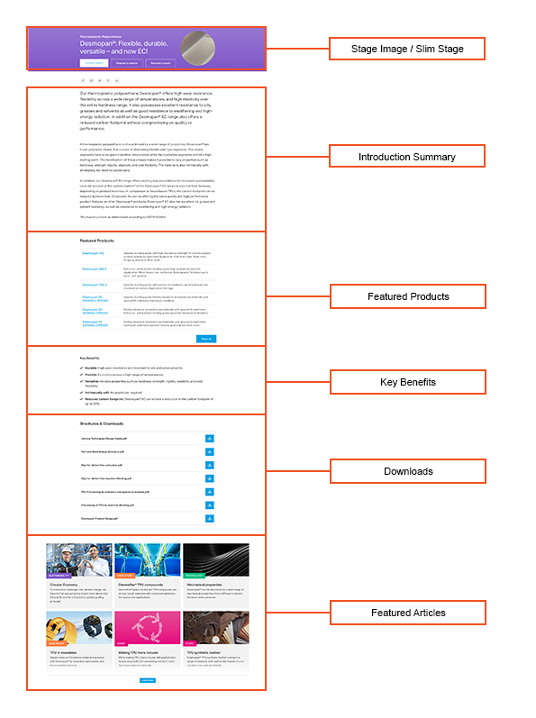

Content template to be filled

Stage and SEO Data Meta description
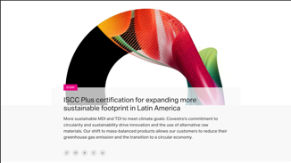 | Max. char. | English Content | Comment(s) / Feedback
Display name | 40 | This is sample content | For URL and item name in content tree (don't use ®, ™ or Umlauts…) - keywords optimization
Navigation title & breadcrumb | 40 |  | Keywords optimization. Special characters (®,™,or umlauts …) allowed
Headline/ Meta title | 55 - 65 |  | For search result snippets, search engine listings and page tabs.  Short title with main keyword in it (search word of target group) for search engines to be shown in search results
(Meta) description | 155 - 160 |  | Short description for search engines to be shown in search results.
Primary Keyword / Keyword Cluster |  |  | Main keyword to be used in H1 and title as well as several times in the text + synonym of keyword. This is what your target group types in the search engine.  E.g: “door installation foam” or “medical grade plastics”  or “mono materials”
Secondary Keywords |  |  | Keyword that are related to your main keyword. They are synonyms ao related to the topic of your main keyword.  E.g: “ pu foam door frame installation” or “medical grade polymers“ or “mono material packaging”  Up to 10 words or word combinations

Introduction copy
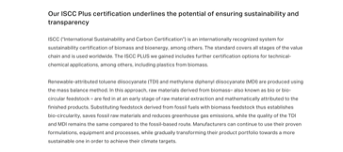 | Max. char. | English Content | Comment(s) / Feedback
Summary | 300
Detailed Description | 800

Featured Products
Up to 6 related products that could be interesting to the customer reading this article
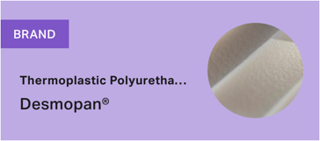 |  | Max. char. | English Content | Comment(s) / Feedback
Priority Region |  |  | [ ] EMLA  [ ] NAFTA  [ ] APAC | For non-global products
Product 1 |  |  |  | Name of highlight product  of brand
Product 2
Product 3
Product 4
Product 5

 | Key Benefits (max. 5)
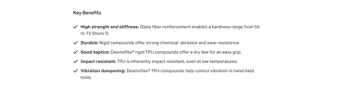 |  | Max. char. | English Content | Comment(s) / Feedback
Benefit 1 Title |  | 20 |  | For consistency of style, please use an adjective rather than a noun where possible. Please follow this with a colon. E.g.: “Flame retardant:”
Benefit 1 Text |  | 80 |  | Short description of benefit in consistent style
Benefit 2 Title |  | 20
Benefit 2 Text |  | 80
Benefit 3 Title |  | 20
Benefit 3 Text |  | 80
Benefit 4 Title |  | 20
Benefit 4 Text |  | 80
Benefit 5 Title |  | 20
Benefit 5 Text |  | 80

Media
 | Max. char. | English Content | Comment(s) / Feedback
Stage Image
480*480px
No text on image! The images will be automatically cropped, and the text may be unreadable.
MediaHub ID
Stage image Alt-Text | 100 |  | Short description of image used if image can’t be displayed
Copyright |  |  | If copyright mention needed, please add it onto the image (for stage and content images) or refer in caption text (only for content images
Downloads

Download 1
Content is gated
Yes ( ) No ( )
Note: We can currently only gate the whole module
MediaHub ID
Display name | 60
Download 2
MediaHub ID
Display name | 60
Download 3
MediaHub ID
Display name | 60
Download 4
MediaHub ID
Display name | 60
Download 5
MediaHub ID
Display name | 60

Social Media Promotion (organic)
LinkedIn
 | Max. char. | English | Characters include spaces and all characters (letters, numbers, symbols and yes, even our precious emojis)
Mandatory to be filled by the BE
Post Target |  | E.g.: Post engagement, LinkedIn reach (impressions), generate SC traffic (clicks, CTR), video views | As briefing information for the copywriter, the following information is essential: What do we want to achieve?  Please provide your most important KPI.  This helps to give recommendations on playout (MyCompany, targeted or to all followers, or to give the draft “the right spin”)
To be filled by the SoMe copy writer
LinkedIn Post Caption  (Proposal) | 3.000 | Limit before “See More” button:  140 characters | Make sure to implement the Key Message within the first two to three lines to get the reader’s attention directly. Can we connect our topic to a current trend/ to sth. a broader audience is interested, the better.  The less promotional the caption, the better we will perceived. ..and the post perform.  Algorithm changes: so we can’t say short or long textures are better. Golden rule should be as long as needed, and as short as possible.  CTA: What should the reader do after reading our posts? (e.g. Learn more, visit us,..)  Profile(s) to be tagged: please prefix with "@" sign.  Include up to 4 #keywords – most if not all, at the end of the texture.
LinkedIn Asset Headline: |  |  | LI Document/Carousel Title: [limited to 58 characters  LI Video Title: [limited to 150 characters]  Image/Thumbnail Headline: [short and crisp]
LinkedIn Asset(s):  Please save the media file under  “add attachment” in Kapost  (no Media Hub Number needed) |  |  | Images need an image headline  (to amplify the message) and a logo.  All documents (carousels, videos; pdfs e.g. article/interview) additionally need a LinkedIn headline / CTA (explicitly for the asset)  With videos we always need a catchy Thumbnail Image (with a headline).

Best practice example
Kapost link: https://covestro.kapost.com/posts/desmopan-brand-page
Solution Center link: https://solutions.covestro.com/en/brands/desmopan

