Information needed for our DES – Eventmodule

The Digital Event Space (DES) works digital-only and as extension (hybrid) to the physical tradeshow. It offers full experience for all target groups that cannot attend the physical event and supports the on-site visitors. When it comes to participation and exclusive information, the eventmodule is the heart of every DES.
For inspiration see: https://solutions.covestro.com/en/events

Please make sure to follow the templates structure.
Once the content is published and changes are made: Please always work in track changes.
Content of this document: Please note that all characters include spaces.

- Mock-up
- Content template to be filled
- Social Media Promotion (organic)

Mock-up

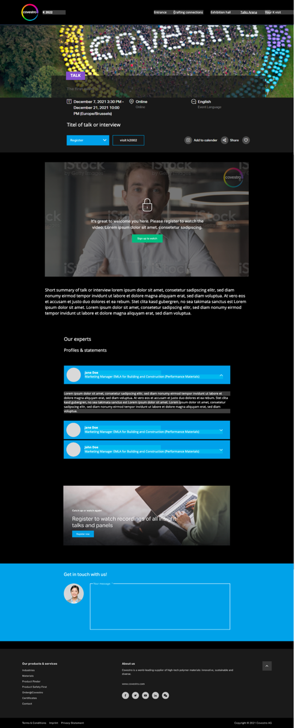

Content template to be filled

SEO Data Meta description
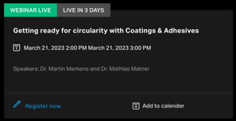 | Max. char. | English Content | Comment(s) / Feedback
Event Type |  |  | E.g. Webinar, DES, Talk, Keynote
Event Title |  |  | E.g.K 2022
Language |  | [X] English  [ ] German  [ ] Chinese
Display name |  |  | For URL and item name in content tree (don’t use ®, ™ or Umlauts …) – keywords optimization, needs to be specific depending on the event type
SEO Data
Meta Title | 25 |  | For search result snippets, search engine listings and page tabs
(Meta) description | 125 |  | Short description for teaser & snippet display and for search engine listings
Primary Keyword |  |  | Main keyword to be used H1 (Introduction title) and throughout content
Secondary Keywords |  |  | Further keywords, up to 10 words or word combinations

 | Stage
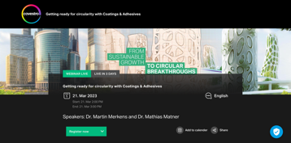 |  | Max. char. | English Content | Comment(s) / Feedback
Stage Image
1920*440 px
Please avoid text on image. The images will be automatically cropped, and the text may be unreadable.

Stage Image |  |  |  | Media Assistant ID  E.g. 8E183234-C085-42C2-B6D4BF79881C032D
Stage CTA |  | 30 |  | E.g. Register now; Get in touch  CTA can trigger a contact form, a newsletter registration or an iCal download
Link in stage |  |  |  | Optional  An additional link can be placed in the stage
Stage H1 |  | 80 |  | Headline naming the event  This HL is shown above the dates
Content tag |  |  | [ ] Conference  [ ] Digital Event  [ ] Keynote  [ ] Talk  [ ] Webinar Live  [ ] Webinar on demand
Add to calendar functionality |  |  | [x] Yes  [ ] No | A calendar file is downloaded via click and can be added to the user's calendar
Start date + time |  |  |  | E.g. 15.04.2023, 1 pm (CET)
End date + time |  |  |  | E.g. 19.04.2023, 2.30 pm (CET)
Time visibility |  |  | [ ] Don’t show date + time  [ ] Remove date + time after event
Speaker Name – 1 |  |  |  | Optional
Speaker Job Title – 1 |  |  |  | Optional
Speaker Company – 1 |  |  |  | Optional
Location |  |  |  | E.g. Germany, Düsseldorf
Location description |  |  |  | E.g. Messe Düsseldorf - Hall 6, Covestro booth (optional)
Language of the event |  |  | [X] English  [ ] German  [ ] Chinese
Event description |  | 300 |  | Intro copy about the event or topic of the talk / webinar / keynote  This is the copy below the dates and will be shown on the event teaser
iFrame (Moving Images live stream or recorded video via Moving Images ID)
Video ID |  |  |  | Moving Images ID
Gated |  |  | [x] Yes  [ ] No
Video caption |  | 100 |  | Optional  E.g. Markus Steilemann at Messe Düsseldorf

Disclaimer: In case you want to set up a Digital Event Space, you can add all possible modules. Please use the correct briefing from the All modules pages
For inspiration see: https://solutions.covestro.com/en/events

Social Media Promotion (organic)
LinkedIn
 | Max. char. | English | Characters include spaces and all characters (letters, numbers, symbols and yes, even our precious emojis)
Mandatory to be filled by the BE
Post Target |  | E.g.: Post engagement, LinkedIn reach (impressions), generate SC traffic (clicks, CTR), video views | As briefing information for the copywriter, the following information is essential: What do we want to achieve?  Please provide your most important KPI.  This helps to give recommendations on playout (MyCompany, targeted or to all followers, or to give the draft “the right spin”)
To be filled by the (Social Media) Copy Writer from above
LinkedIn Post Caption  (Proposal) | 3.000 | Limit before “See More” button:  140 characters | Make sure to implement the Key Message within the first two to three lines to get the reader’s attention directly. Can we connect our topic to a current trend/ to sth. a broader audience is interested, the better.  The less promotional the caption, the better we will perceived. ..and the post perform.  Algorithm changes: so we can’t say short or long textures are better. Golden rule should be as long as needed, and as short as possible.  CTA: What should the reader do after reading our posts? (e.g. Learn more, visit us,..)  Profile(s) to be tagged: please prefix with "@" sign.  Include up to 4 #keywords – most if not all, at the end of the texture.
LinkedIn Asset Headline: |  |  | LI Document/Carousel Title:  [limited to 58 characters]  LI Video Title: [limited to 150 characters]
LinkedIn Asset(s):  Please save the media file under  “add attachment” in Kapost  (no Media Hub Number needed) |  |  | Images need an image headline  (to amplify the message) and a logo.  All documents (carousels, videos; pdfs e.g. article/interview) additionally need a LinkedIn headline / CTA (explicitly for the asset)  With videos we always need a catchy Thumbnail Image (with a headline).

