 | Accordion Module
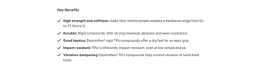 |  | Max. char. | English Content | Comment(s) / Feedback
Section 01
Icon (optional)
1655*1655 px
Title Section 01 |  | 60
Subtitle Section 01 (optional) |  | 30
Copy 01
Section 02
Icon (optional)
1655*1655 px
Title Section 02 |  | 60
Subtitle Section 02 (optional) |  | 30
Copy 02
Section 03
Icon (optional)
1655*1655 px
Title Section 03 |  | 60
Subtitle Section 03 (optional) |  | 30
Copy 03
Section 04
Icon (optional)
1655*1655 px
Title Section 04 |  | 60
Subtitle Section 04 (optional) |  | 30
Copy 04
Section 05
Icon (optional)
1655*1655 px
Title Section 05 |  | 60
Subtitle Section 05 (optional) |  | 30
Copy 05
Section 06
Icon (optional)
1655*1655 px
Title Section 06 |  | 60
Subtitle Section 06 (optional) |  | 30
Copy 06

